**Week 6**

**ReactJS**

1. **Program:**

import React from 'react';

function App() {

return (

<div>

<h1>Welcome to the first session of React</h1>

</div>

);

}

export default App;

**Output:**

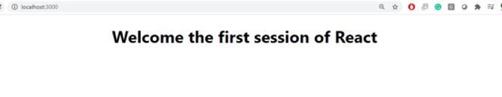

**2.Program:**

**App.js**

import React from 'react';

import Home from './Components/Home';

import About from './Components/About';

import Contact from './Components/Contact';

function App() {

return (

<div className="App">

<Home />

<About />

<Contact />

</div>

);

}

export default App;

**Home.js**

import React from 'react';

function Home() {

return (

<div>

<h2>Welcome to the Home page of Student Management Portal</h2>

</div>

);

}

export default Home;

**About.js**

import React from 'react';

function About() {

return (

<div>

<h2>Welcome to the About page of the Student Management Portal</h2>

</div>

);

}

export default About;

**Contact.js**

import React from 'react';

function Contact() {

return (

<div>

<h2>Welcome to the Contact page of the Student Management Portal</h2>

</div>

);

}

export default Contact;

**Output:**

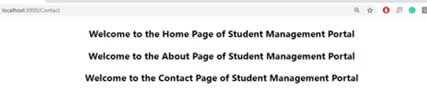

**3.Program:**

**CalculateScore.js**

import React from 'react';

import '../Stylesheets/mystyle.css';

function CalculateScore() {

const name = "John Doe";

const school = "Springfield High";

const total = 450;

const goal = 500;

const average = (total / goal) * 100

return (

<div className="score-container">

<h2>Student Score Details</h2>

<p><strong>Name:</strong> {name}</p>

<p><strong>School:</strong> {school}</p>

<p><strong>Total :</strong> {total}</p>

<p><strong>Score:</strong> {average.toFixed(2)}%</p>

</div>

);

}

export default CalculateScore;

**mystyle.css**

.score-container {

margin: 30px auto;

padding: 20px;

border: 2px solid #007bff;

border-radius: 10px;

width: 400px;

text-align: left;

font-family: Arial, sans-serif;

background-color: #f0f8ff;

}

.score-container h2 {

color: #007bff;

margin-bottom: 15px;

}

App.js

import React from 'react';

import './App.css';

import CalculateScore from './Components/CalculateScore';

function App() {

return (

<div className="App">

<CalculateScore />

</div>

);

}

export default App;

**Output:**

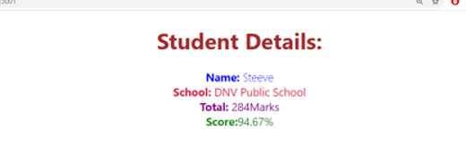

**4.Program**

**Post.js**

import React from 'react';

import Post from './Post';

class Posts extends React.Component {

constructor(props) {

super(props);

this.state = {

posts: [],

error: null,

};

}

loadPosts = () => {

fetch('https://jsonplaceholder.typicode.com/posts')

.then((response) => {

if (!response.ok) {

throw new Error('Failed to fetch posts');

}

return response.json();

})

.then((data) => {

this.setState({ posts: data });

})

.catch((error) => {

this.setState({ error });

});

};

componentDidMount() {

this.loadPosts();

}

componentDidCatch(error, info) {

alert(`An error occurred: ${error.toString()}`);

}

render() {

const { posts } = this.state;

return (

<div style={{ padding: '20px' }}>

<h2>Blog Posts</h2>

{posts.map((post) => (

<Post key={post.id} title={post.title} body={post.body} />

))}

</div>

);

}

}export default Posts;

**App.js**

import React from 'react';

import './App.css';

import Posts from './Posts';

function App() {

return (

<div className="App">

<Posts />

</div>

);

}

export default App;

**5.Program**

**CohortDetails.js**

import React from 'react';

import styles from './CohortDetails.module.css';

function CohortDetails({ cohort }) {

return (

<div className={styles.box}>

<h3 style={{ color: cohort.status === 'ongoing' ? 'green' : 'blue' }}>

{cohort.name}

</h3>

<dl>

<dt>Status:</dt>

<dd>{cohort.status}</dd>

<dt>Start Date:</dt>

<dd>{cohort.startDate}</dd>

<dt>End Date:</dt>

<dd>{cohort.endDate}</dd>

</dl>

</div>

);

}

export default CohortDetails;

**CohortDetails.module.css**

.box {

width: 300px;

display: inline-block;

margin: 10px;

padding: 10px 20px;

border: 1px solid black;

border-radius: 10px;

}

dt {

font-weight: 500;

}